Pizza Sales SQL Analysis – Full Query Document
This Document contains all SQL queries used for analyzing the pizza sales dataset. Queries are organized with headings for clarity.

- Dataset Overview : The dataset consists of pizza sales transactions, including details such as order date, order time, pizza category, pizza size, quantity, unit price, and total price. SQL queries were used to clean, aggregate, and extract meaningful insights from the dataset.

- SQL Queries Used for Analysis Below is a collection of SQL queries used for cleaning, aggregating, and extracting business insights from the pizza sales data.

Q1 Which pizzas generate the highest ttl revenue,also followings (4)?

SELECT TOP 5
pizza_name,
ROUND(SUM(total_price),1) AS revenue_IN_$
FROM dbo.pizza_sales
GROUP BY pizza_name
ORDER BY sum(total_price) DESC;
-- if you want bottom 5 then simply REPLACE "DESC" with "ASC"

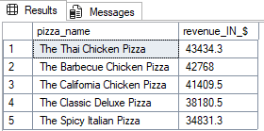
Q2 What are the top 5 most ordered pizzas by quantity (best sellers pizzas)?

SELECT TOP 5
pizza_name,
SUM(quantity) AS total_qty_sale
FROM dbo.pizza_sales
GROUP BY pizza_name
ORDER BY SUM(quantity) DESC;
-- if you want to worst sellers then replace "DESC" with "ASC"
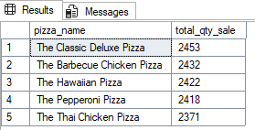
Q3 Which pizza size contributes the most to total sales?

SELECT
pizza_size,
ROUND(SUM(total_price),1) AS revenue_in_$
FROM dbo.pizza_sales
GROUP BY pizza_size
ORDER BY SUM(total_price) DESC;

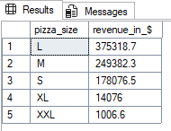

Q4 Revenue trend by date (daily sales trend)?

SELECT
tt.order_date,
tt.daily_sales_$,
ROUND(daily_sales_$ - trends,1) AS daily_sales_trnds_$
FROM(
SELECT
order_date,
ROUND(SUM(total_price),1) AS daily_sales_$,
LAG(ROUND(SUM(total_price),1)) OVER(ORDER BY order_date ASC) AS trends
FROM dbo.pizza_sales
GROUP BY order_date
) tt
ORDER BY order_date ASC
;
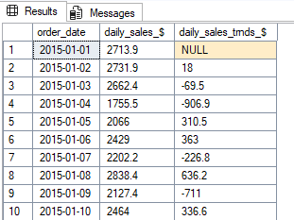
Q5 What is the hourly order pattern (peak hours) TOP(5)?

SELECT TOP 5
DATEPART(hour,order_time) as hour_frame,
SUM(quantity) AS total_orders
FROM dbo.pizza_sales
GROUP BY DATEPART(hour,order_time)
ORDER BY SUM(quantity) DESC
;
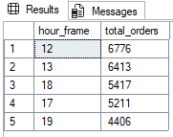
Q6 Which pizza category brings the most revenue?

SELECT
pizza_category,
ROUND(SUM(total_price),1) AS revenue_$
FROM dbo.pizza_sales
GROUP BY pizza_category
ORDER BY ROUND(SUM(total_price),1) DESC;

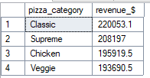
Q7 What is the average order value (AOV)?

SELECT
ROUND(AVG(tt.avg_order),2) AS avg_order_value_$
FROM(
SELECT
order_id,
ROUND(SUM(total_price),2) AS avg_order
FROM dbo.pizza_sales
GROUP BY order_id
)tt;

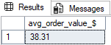

Q8 Find the most commonly used ingredient combinations?

SELECT
pizza_ingredients,
COUNT(*) AS pizza_ingredients
FROM dbo.pizza_sales
GROUP BY pizza_ingredients
ORDER BY COUNT(pizza_ingredients) DESC;

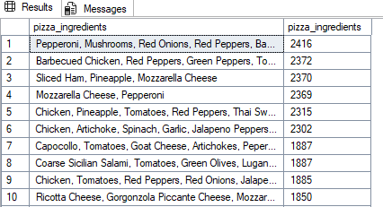
Q9 Which pizzas have the highest price (premium items)?

SELECT TOP 3
pizza_name,
ROUND(MAX(unit_price),2) AS unit_price
FROM dbo.pizza_sales
GROUP BY pizza_name
ORDER BY unit_price DESC;

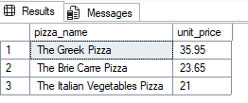
Q10 Average pizza per order ?

SELECT
CAST(AVG(tt.quantity_ordered) AS FLOAT) AS avg_pizza_per_order
FROM(
SELECT
order_id,
SUM(quantity) AS quantity_ordered
FROM dbo.pizza_sales
GROUP BY order_id
)tt;

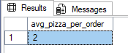

Q11 Which weekday max number of customers placed orders ?

SELECT
DATENAME(DW,order_date) weekday_,
COUNT(DISTINCT order_id) as ppl_placed_order
FROM dbo.pizza_sales
GROUP BY DATENAME(DW,order_date)
;
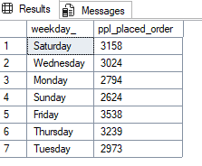
Q12 Which month max number of customers placed orders ?

SELECT
DATENAME(MONTH,order_date) month_name,
COUNT(DISTINCT order_id) as ppl_placed_order
FROM dbo.pizza_sales
GROUP BY DATENAME(MONTH,order_date)
ORDER BY COUNT(DISTINCT order_id) DESC
;

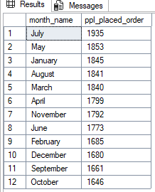

Q13 Which category sales contributed max % ?

SELECT
tt.pizza_category,
ROUND(tt.sale_$,2) AS sale,
ROUND(sale_$*100/total_sale_$ ,1) as percent_contri

FROM(
SELECT
pizza_category,
SUM(total_price) as sale_$,
(SELECT
SUM(total_price)
FROM dbo.pizza_sales) AS total_sale_$
FROM dbo.pizza_sales
GROUP BY pizza_category)tt
ORDER BY percent_contri DESC;

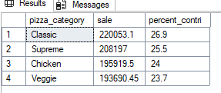
Q14 Which pizza_size sales contributed max % ?

SELECT
tt.pizza_size,
ROUND(tt.sale_$,2) AS sale,
ROUND(sale_$*100/total_sale_$ ,1) as percent_contri

FROM(
SELECT
pizza_size,
SUM(total_price) as sale_$,
(SELECT
SUM(total_price)
FROM dbo.pizza_sales) AS total_sale_$
FROM dbo.pizza_sales
GROUP BY pizza_size)tt
ORDER BY percent_contri DESC;

